# HTML FORMS CHALLENGE

Your task is to design the form elements used to create the form shown in Figure 1.

In addition to looking like the form shown in Figure 1, your form must include the constructs listed in the following instructions. When creating the code for your form, you must use the HTML5 tags that are appropriate to replicate the form and fulfill all the specifications listed.

1. Code the form with autocomplete active.
2. Given the image shown in Figure 1, it is easy to see that two field sets are used to create the main structure of the form. Your task is to create the field sets, including the names Customer Info and Books. Don't worry about the content fields for the moment.
3. The Name field you create should have autofocus, placeholder text, and be required. Don't forget to select the appropriate type for this field as well as all the fields that follow.
4. The Telephone field should have placeholder text, a pattern to restrict entry, and be required.
5. The Email address field should have placeholder text and allow multiple entries. This field should also be required.
6. The Books field should have a data list. You can select the content you would like to list. Add at least 5 textbooks
7. The Quantity (Maximum 5) field should have a minimum value of 1 and a maximum value of 5.
8. Add your own background to the body of the

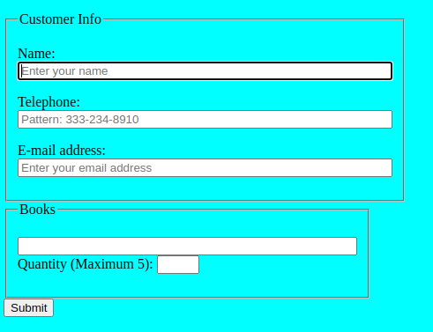  
Figure 1

# TASK 2

Create the following signup form (using only HTML)

#### Other requirements

* Add an extra field named secret to the form.
* Its value should be set to 12345.
* We don't want the user to be able to see it.

